Tableau Users Group December 2019
- Hack to get more than 16 columns
- Creating a Calendar
- Control measures using a parameter
- Adding color palettes
- Adding custom shapes to the marks card

More than 16 Columns
This is not recommended by Tableau, but I learned it from a Tableau conference. Tableau will increase the 16 column limit to 50 in a future release.
- Make a copy of your report should something goes wrong.
- Go to Analysis/Table Options/Advance and note the max levels for the rows and column
- Got to your Tableau workbook and right click on it and open in a text editor. Do not use Word since this may add unwanted characters to the document.
- Look for the following strings where x represents the current column and row settings noted in step 2.
<format attr='row-levels' value='x' />
<format attr='row-horiz-levels' value='x' />
<format attr='col-levels' value='x' />

- Change the values to the number of rows and headers you actually need. In this example I chose 20.
<format attr='row-levels' value='20' />
<format attr='row-horiz-levels' value='20' />
<format attr='col-levels' value='20' />

- Save and close the file. Reopen the file in Tableau and you should see the column headings are no longer concatenated.

Creating a Calendar

You can create a calendar in Tableau to show off your measures by following these simple steps:

- Create an Excel file with the date range for your calendar – or use our Date Dimension table. I will use an Excel file
  - Open Excel
  - Create your first date – 1/01/2018
  - Drag the cell down to fill in your date range – in the example 12/31/2018
  - Save the file
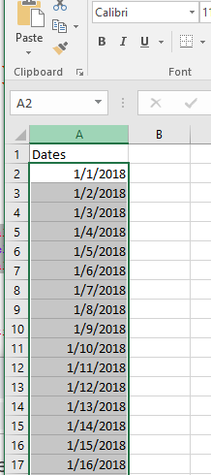
- Open up Tableau and connect to your data. I will use the Sample Super
- Select Data on the menu bar and New Data Source
- Choose your Excel file. You should now see both data sets.
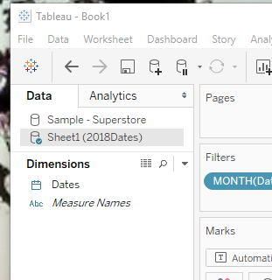
- Working with just your dates from the Excel file, start building your framework. The reason you use the Excel file is that every date is represented. If you are certain your data file has every date, then you can skip the Excel file.
  - Drag Dates to Column shelf and select the discrete custom month/Yearth. This is done by clicking on the down triangle and selecting more from the first set of date options.
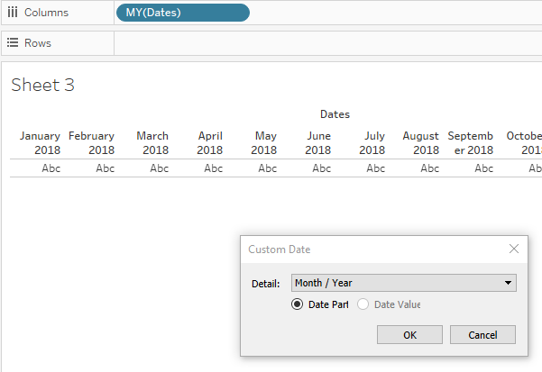
  - Drag Dates to the column shelf a second time and choose Weekday
  - Drag Dates to the row shelf and choose Week Number
  - Drag Dates to the filter box and choose Month/Year then choose a single month. Your calendar should look like the following:
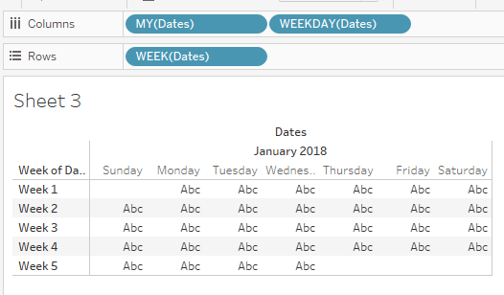
  - Click on the down arrow for the Dates on the row shelf and uncheck show header. This will remove the Week 1, week 2, etc.
- A relationship needs to be established between the Excel Dates and the Sample Superstore. I will be joining the Dates to the Order Dates from the Superstore.
  - Click on Data in the Tableau Menu bar
  - Select Edit Relationships
  - Click Add
  - The dates show up on the Primary source. Select Order Date on the secondary data source column
  - Click OK
  - You should see a link mark next to the order date
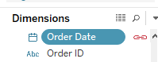
- On the marks card select Square marks and increase the size by clicking on the size mark and adjusting.
- Drag Dates from the Excel data source and drop it on the Label mark and you should see the days of the week display. Don’t worry about the fit just yet.
- Move Profit to color. You now have color squares with the dates appropriately labeled.
- Final Formatting
  - Click on the word Dates (or what your excel labels says) and hide the label.
  - Right click on your calendar and select Format
  - With the sheet tab selected, click on the Border box and set the cell value to a line. You have the option of choosing the color when you set this.
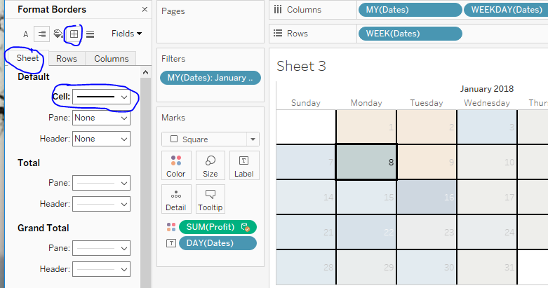
  - Close the Format panel
  - You can click on the Color mark and choose a different set of divergent colors if you wish

Switch between Measures

There are times when you will want to use one viz but select which measure is to be displayed. We will use the calendar example and set it up to switch across Profit, Quantity, and Sales. A parameter is used to accomplish this.

- Create a parameter called Super Store Activity
  - Select data type to be string
  - Set Current Value to Profit (this can be entered after list is created)
  - Click on List and enter the values as shown below. Display As is what the user will see when making a measure selection. The list of values is what will be used in the calculated field. Type in something that is meaningful.
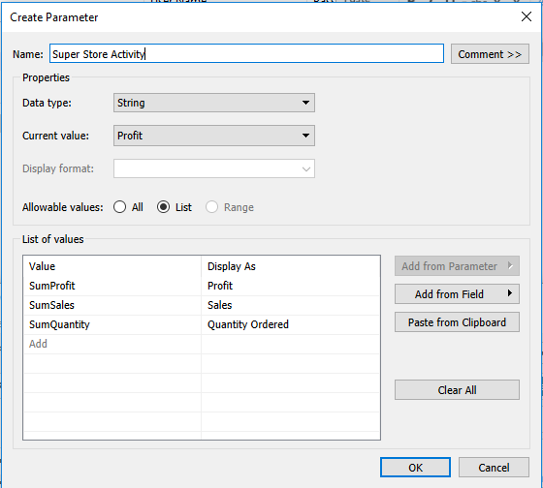

- Create a calculated field to match the parameter as shown below using the parameter title and values created in step 1.

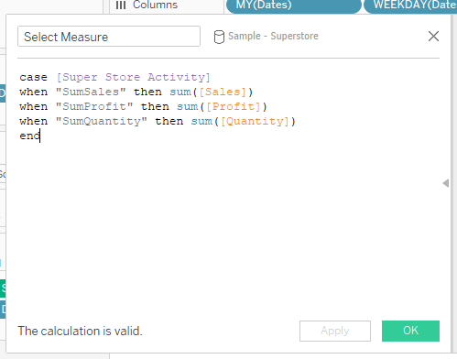

- On the Parameter, click on the dropdown and select Show ‘Parameter Control’
- Remove the Profit measure from the calendar and place the calculated field ‘Select Measure’ onto the color mark.
- Select the Super Store Activity and you will see the colors change accordingly.

Adding a Color Palette

Tableau comes with a large color palette. However, there may be times where you may want to develop your own palette or add our Rice recommended palette to your existing palette. The steps to create custom palettes are the steps to follow.

- Go to your Tableau repository. The default location is in your Documents folder under My Tableau Repository.
- Make a copy of Preferences.tps, and give is a name such as Preferences.tps.20191205
- Copy and paste the Rice color palette (when available) into the preferences.tps file
- Save the file. Close Tableau and re-open. You should see the new palette.

The format of the palette resembles the following:

<?xml version='1.0'?>
<workbook>
<preferences>
<color-palette name="Rice Basic Custom Palette - Regular" type="regular">
<color>#1a2066</color>
<color>#928f8f</color>
<color>#034ea2</color>
<color>#0e113e</color>
<color>#494546</color>
<color>#d1cbcd</color>
<color>#3b82a0</color>
<color>#96b8d2</color>
<color>#a0ddf9</color>
<color>#4d9ad4</color>
</color-palette>
</preferences>
</workbook>

Each new palette starts with a Palette name followed by the Hex list of colors and ends with </color-palette> line.

Adding Logos or Special Shapes

Shapes can be added to the Tableau Shapes marks card by the following steps
- Go to your Tableau Repository and opening the Shapes folder
- Create a new folder with the name of your new collection of states. I created a directory called States
- Put in the desired images. These can be .jpg, .gif, .png. Tableau uses .png files for their repository. The sizing of shapes is important. Tableau recommends 32 x32 pixels
- When building a report and you select the Shape marks, you will see your new directory in the dropdown box.
- The example below shows an example of state symbols being added to a graph chart.

Note: Palettes and Shapes are stored in the local repository. If you share a viz with someone who doesn’t have these colors or shapes, they will not appear. However, when you publish your viz to the Tableau server with the ‘Include external files’ checked, the shapes and colors will be saved with the viz.

