Katy ISD Presentation:

Tableau Training
https://www.tableau.com/learn/training

Blogs
Datablick.com
Learningtableaublog.wordpress.com

Tip 1 – On a dashboard – click on container tab to move it around

Tip 2 – Put comments on a calculated field use //

TIP 3 – When creating a spreadsheet and you place a measure in the measure column, you will not see a column heading

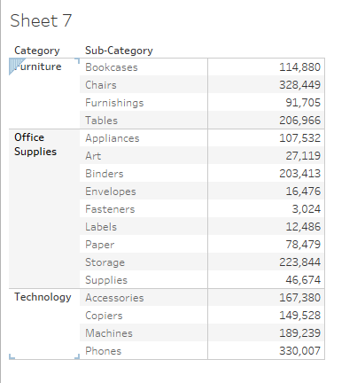

To correct for this
- Double click on the column shelf.
- Enter the name of your column header inside either single or double quotes. You will see your column heading written twice on the viz, with and without the quotes.
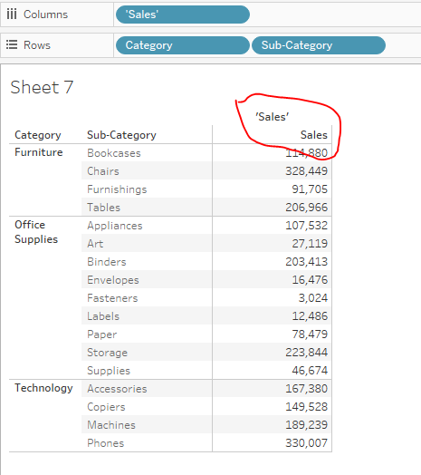
- Mover cursor to the viz and right click on the header within the quotes.
- Select ‘Hide field labels for columns’
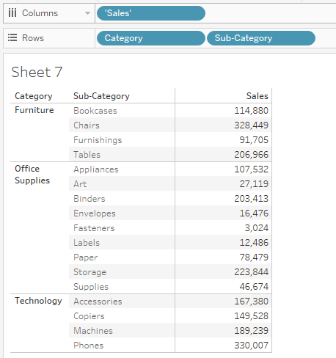

Tip 4 – To format the measure column, click on the text box in the Marks card. Click on the ellipses to pull up the format box for the measure.

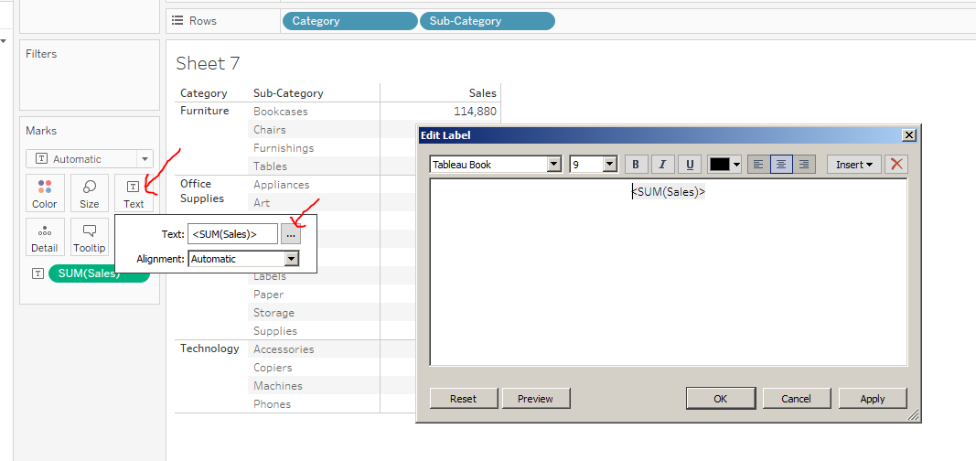

Tip 5 – when not using the measures column and you don’t want to see it
- Go to Marks card and select polygon
- Move the right most column divider to the left to shrink it as much as possible
- Go to Format Boarders and click on column tab
- At the bottom, click on Column Divider and select None.

Tip – 6 you can do an ad-hoc calculation by simply by right clicking on the column shelf.

