Two KPI’s on One Worksheet
Developed by Robert Rouse, Interworks
Interworks – https://interworks.com/blog/rrouse/2015/12/14/new-way-visualize-kpis-tableau

Issue: would like to create two separate vizes on one work sheet so I can scroll performance KPI’s in unison.
In this example I want to see how my sales reps are performing
- If they met sales target for the 4 year total
- Sales performance over time
Viz to be created using the Tableau Superstores dataset:
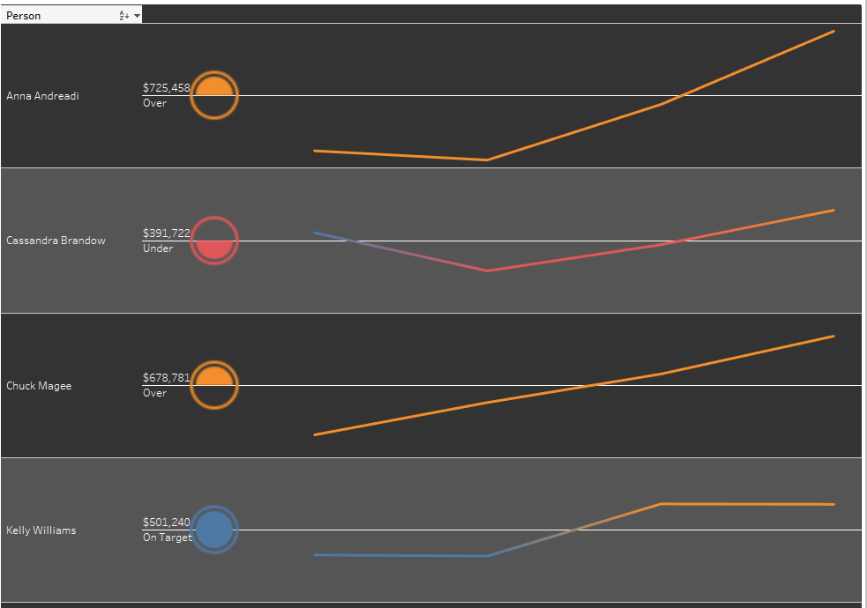

- Create calculations for the 4 year target – display Under, On Target, and Over. This will be the shape chart
Total Target:
IF
sum([Sales]) < 500000 then "Under"
elseif sum([Sales]) > 500000 AND sum([Sales])< 650000 then "On Target"
ELSE "Over"
END
- Create calculation to display Under, On Target, and Over across the 4 years. This will be the line chart.
Annual Target
IF
sum([Sales]) < 100000 then "Under"
elseif sum([Sales]) > 100000 AND sum([Sales])< 120000 then "On Target"
ELSE "Over"
END
- Create a Calculation for the Axis.
Axis
//stoplight icon, no quarterly detail, right on the target line
//This counts the number of data points in the set and if it is 1 it assigns it a value of zero.
//This is for the circle
if
window_sum(1)=1 then 0
ELSE
//trend, plot diff from midpoint
//This equations sets data points above and below the medium value
sum([Sales])-((window_max(sum([Sales]))+window_min(sum([Sales])))/2
)
END

- Create a Parameter Calculation for a dummy field. Name 0.0, current value 0, float. In order for the chart to work, the value must be a measure. You can name this parameter anything.
- On the Column Shelf, drag the Order Date field and the Parameter 0.0 in that order. Be sure to make the date field continuous. Arrange the order so 0.0 appears first on the shelf.
- On the Rows shelf, drag your sales people, Person field, and the Axis calculated field.
- On the 0.0 marks card, select shapes and perform the following steps:
  - Drag Total Target calculation and drop it on shapes.
  - Select Ratings shape and assign the values.
  - Click on the size mark and increase the size to something appropriate.
  - Drop Total Target calculation on Color. Assign the colors to the object.
  - Drag Sales and Total Target to Label. Edit the label to be left and center justified. Increase the column width as needed.
- On the Year marks card, select Line if not already selected.
  - Drag the Annual Target calculation onto color.
  - Edit the color to reflect the same color as step 7.

Formatting the Viz (optional)
- Eliminate the 0.0 title and 0 value from the axis under the stoplight
  - Right click on the 0.0, and select edit axis.
  - Remove the axis title at the bottom of the General tab.
  - Click on the Tick Marks tab and select None for both the major and minor tick marks and close the Edit Axis window.
  - If you don’t want to see any titles, right click and uncheck Show Header.
- The columns are fixed to the same size. To allow Tableau to adjust the image size, right click anywhere on the viz and select Clear Manual Sizing. This expands the Line chart.
- To set banding and chart color
  - Right click on viz and select format.
  - Click on the Shading icon (paint bucket on the top) and set the worksheet color to a dark gray.
  - Click on row banding for pane and select a slightly lighter color for the band. Repeat with the same color for the Header.
    - Band size indicates how many rows are banded together.
    - Level indicates if the bands extend to the Header. Move this lever to the left.
  - Click on the A at the top of the menu item to format the text and
    - set the color for the worksheet to white
    - Set the color for the Pane to white
- Select Rows then select Lines
  - Set Grid Lines to none.
  - Set Zero Lines to a Bar, select narrow bar, and color white.
- Select Columns then select Lines
  - Set Zero Lines to None.
  - Set Grid Lines to None.
  - Click on Borders and set Column Divider to None.

